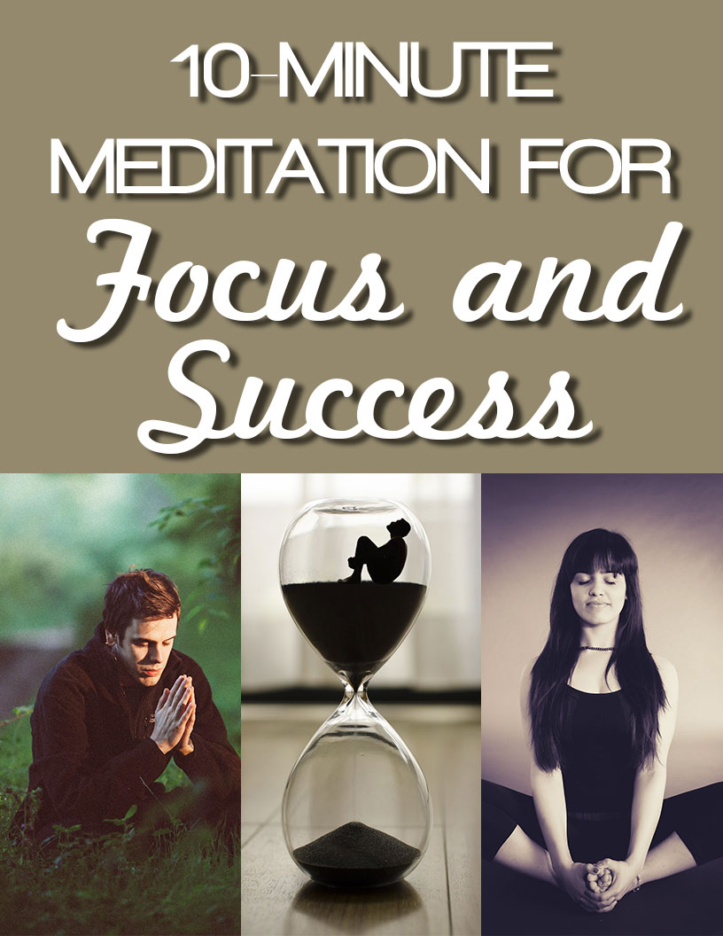
The Power of Meditation

Today’s world, thankfully, is changing. People are incorporating more holistic practices and mindful practices into their daily lives. From children to elders, meditation is one of those practices.

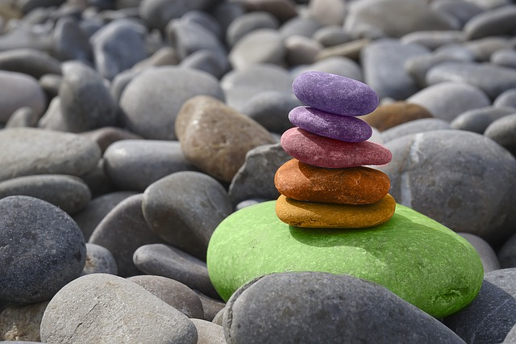
We all know someone who takes on the practice of meditation. For some people, it’s a daily practice, while for others it’s just for emergency situations. What are some of those emergency situations? It’s those moments where you feel like your life is spinning out of control. It’s for times when you can’t seem to get out of your own way.

Can you become one of the masses and take on the practice of meditation, as well? Does it sound like it’s too time consuming and not worth the trouble? If you think this way, you’ll be in for an extremely pleasant surprise. Not only is meditation most certainly worth the time and effort, but the rewards will speak for themselves.

There are so many benefits to meditation which will delight and surprise you. First of all, let’s get into the subject of what meditation really is. Some people think you have to be a highly spiritual person or an expert in meditation with a certification to your name.
This is not the case. Meditation is available for everyone, and why not? It has a multitude of benefits.

What is Meditation?

The practice of meditation has been around for centuries. People have used it for religious purposes and cultural reasons. There are as many forms of meditation as there are practices.

The art and practice of meditation basically has one goal in mind – to slow down the mind. Especially in today’s culture, we all have such busy lifestyles and even busier minds. Stress levels are up, blood pressure is up and relaxation is down. This is where meditation comes into play.

The art and practice of meditation is one where you allow yourself and, most importantly, your mind to relax, rest, and rejuvenate itself. You take time to practice the art of breathing, slowing down your mind and coming back to center.

What is center? Center is the place where your deepest desires live and breathe. It’s the place where you can move forward from and get back on track. The true history of meditation is really the practice of getting into a thought consciousness of total awareness and not letting the mind wander.
However, this is something that takes time and practice. The history and background of meditation is to serve one higher purpose. That purpose is to be in and experience present-moment living.

What is the Power of Meditation?

While some people might view meditation as some sort of woo woo practice which doesn’t really work, the truth of the matter is that there is power behind meditation. When a person meditates, your brain waves change. Meditation actually has the power to change your mind, or at least your mindset.

When someone meditates, their brain waves have the capacity to slow down. With proper breathing techniques, beta waves in the brain are more easily reduced. When the beta waves calm down and slow down, there’s sense of overall calm and well-being as an after effect.

Meditation affects the brain and its brain waves. Each part of the brain, according to scientific studies and research, is affected by meditation. Incoming information can be slowed down when meditating:
- Emotions are not as strong
- Sensory input slows down
- Over-thinking ceases
- Information overload slows down

There are several parts of the brain which are positively impacted by meditation:
- Frontal lobe
- Parietal lobe
- Thalamus

Imagine being able to control your brain to some degree and be able to relax, focus, and have more clarity. All this can come from meditation.

Why So Many People Use and Promote Meditation

Why do so many people use and promote meditation? The answer is because it works. Meditation is successful for many reasons.

Meditation Decreases Anxiety

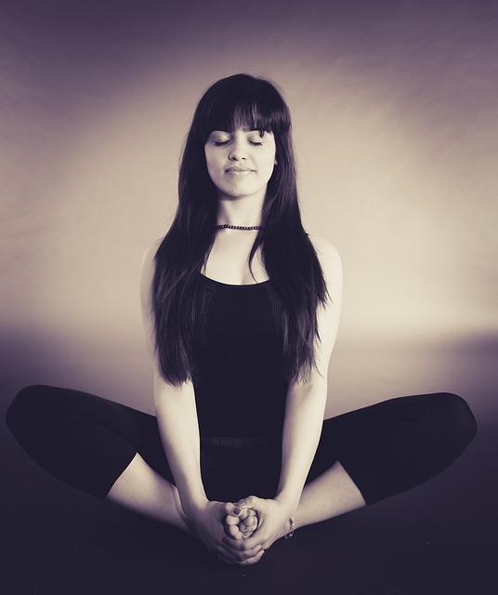
Some people have what is known as too much fight or flight syndrome. Their gut instincts tell them they are in danger when they are really not. Meditation can help ease anxiety.

There’s a neural pathway which leads to the part of our brains in which we need to determine whether or not we are in real, imminent danger. For some, those connections are so strong we feel we are in danger when we are not.

When taking on the practice of meditating, this connection can be diminished, however, this is not a danger. This is a plus. Our brains have many parts, and the part that assesses reasoning is strengthened by meditating, while the irrational fear pathway is weakened.

This becomes a win/win situation.

Meditation Can Allow You to Become More Emphatic

During meditation, the part of your brain that is responsible for showing more compassion is activated. Scientific studies show that compassion and empathy are more active when someone meditates.
Having more compassion is never a bad thing.
Meditation Can Increase Focus
It makes sense that meditation can increase focus because when you meditate, you are focused on the present moment. Present moment awareness trains the brain to stay focused.

One of the biggest bonuses and benefits of meditation is to help you choose your focus and to pull your thoughts back to present moment reality. How often do you catch yourself having a busy brain and feel as though you are not able to reel it back in? Meditation can help with that.

Not only does meditation help you to regain a sense of the present moment while you are meditating, but the effects far outweigh the present moment meditation. Meditation helps you to keep focused long after you’re done meditating.

Meditation Improves Memory

If you’ve ever walked into another room and wondered why the heck you went in there, maybe just meditation can give your memory a boost. Meditation activates a certain part of the brain which helps to decrease distractions and increase memory recall.

So, the next time you walk into a room, you might just remember why you went in there in the first place.

Meditation Unlocks Creativity

If you’ve ever gotten stuck on creating a new idea or had the experience of writer’s block, you may wish to take up meditation. Meditation has a way of unlocking and unleashing creative potential.

In just about any job scenario, creativity is a useful asset. Whether you are a sales and marketing manager or a writer, a little creativity goes a long way.

Meditation Helps You Alleviate Stress Better

When stress arises, you are faced with a fight or flight sensation. You either need to take flight and run away to protect yourself or you need to stay and fight. Neither of these responses promotes peace and healing.

When you take on the daily practice of meditating, you have the ability to alleviate stress more. However, and more importantly, you get to alleviate stress with more ease and grace. Taking on meditation as a daily practice doesn’t only just serve you in the moment. It serves you throughout your day, your week and your life.

Meditation Can Make You Smile More

People who meditate are shown to be more positive and upbeat. Meditation has a way to calm and soothe the mind. When your mind is calm, your spirit is bound to follow. The mind-body connection is a powerful bond.

When you have a calm mind, you are more focused and can therefore be more successful. When you have a mind full of clutter, it’s difficult to focus at work. When you have clarity, you have momentum and therefore you have success. When you are less stressed, you are more focused.

Meditation Helps You to Increase Brain Function

Meditation is like exercise for your brain. While it may not be a muscle, but rather an organ, it does act like a muscle. The more you use it, the better it can get. Meditation has many ways of increasing your brain’s ability to function better.

There are a host of neurological benefits to the brain from meditating. Whereas before it was once thought that only a region or two of the brain was positively impacted, new studies are beginning to show many areas of the brain are positively affected.

The improvements are not just temporary either - they are long-lasting effects.

Can Meditation Slow Down the Aging Process?

The length of telomeres in your brain can determine the length of your life. When it comes down to it, the less stress and anxiety, the less disease and the longer your life.

Now scientific studies and research are showing that the more a person meditates, the more it benefits in keeping aging at bay. It stands to reason that if meditation keeps illnesses at a decreased level, longevity will increase.

A reduced response to stress can have someone lead a happier, healthier, and longer life.

Improving Sleep

Hundreds of thousands of people take sleep aids in order to assist them in getting a decent night’s sleep. These people suffer greatly from insomnia. No matter what they do it seems they keep tossing and turning and sleep just won’t come to them.

They wake up in the morning feeling groggy and irritated, not to mention that without proper sleep it’s easy to get rundown or even sick. Meditation can help improve the quality of your sleep and make it easier to fall asleep and stay asleep.

Here are three ways to incorporate meditation into your nightly routine so that you may experience a more blissful sleep.

- Breathing – practice the art of meditative breathing. Meditative breathing slows the body and mind down. This is conducive to a good night’s rest. More importantly, it slows the activity in your brain so you can prepare yourself for a good night’s sleep.
- Breathing in through your nostrils and exhaling through your mouth is a good way to alleviate stress, let it all go, and slow down your body’s rhythm. Slowing your body and mind down before bed is integral to getting a good night’s rest. More importantly, it is a great way to wake up feeling refreshed rather than groggy and craving more sleep.
- Affirmations – it helps to use a releasing affirmation when you prepare to go to sleep at night. When you prepare to go to sleep at night, it works wonders to mix your deep breathing along with your affirmations. Make certain your affirmations are releasing affirmations. Choose whatever works for you; for example, “I release all that did not serve me today.”
- Visualization – visualizing along with deep breathing and affirmations is a powerful trio. Visualizing your life as you wish it to be doesn’t make you ungrateful, it just leads you to a place where you accelerate the momentum to where you want to be.
What are the benefits of a good night’s rest?
- When you are well-rested, you are more productive
- When you get a good night’s sleep, you are more focused
- When you are more focused, you are more successful
While these are some of the benefits of a good night’s sleep, it’s important to explore which techniques to use and what they are.

Meditation Techniques and Practices to Get You Started
Centering

How often have you heard you need to return to center when meditating? Simply put, centering means to return to your home base. Throughout your day, your night and your week, check in with yourself. How many times do you find yourself thinking about a million things all at the same time?

With so many activities and responsibilities to take care of, it’s easy to get caught up in the daily mindset of having a busy mind. Centering will help to gently and easily guide you back to your central foundation.

That foundation is, or at least should be, one of peace. When meditating, you will begin the practice of gently bringing your thoughts back to the present moment of awareness. You will begin to train your mind not to think upon anything else other than what’s in the present moment.

Grounding
Grounding is similar to rooting. You ground yourself when you connect to the energy of the earth. Walking barefoot in the grass or standing outside while your bare feet connect with the earth is a great way to ground yourself.

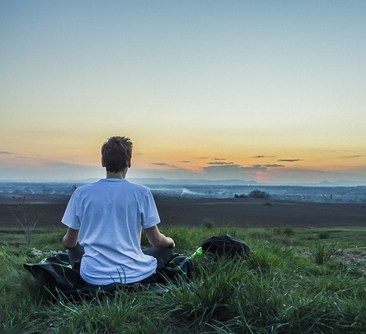
Nature has a way of healing us and when we connect with nature, it’s like a return home. While it’s not always possible to get out barefoot in the grass or dig your bare feet into the mud, you can always use your imagination. While it might sound unusual, the act of visualization incorporated with meditation works wonders.

You can start by getting as comfortable as you can. For some, this means sitting on a blanket or pillow on the floor. For others, it means lying on their back on the bed. And still others find much success standing up imagining their feet grounding into the earth.

Imagine you are standing tall in a forest deep in the woods somewhere. Begin to breathe in slowly on a count to five. When you breathe in, take some time to create a statement that has a positive affirmation to it.

You could even envision you are breathing in new energy as you prepare to release stagnant old energy. As you envision yourself connecting the soles of your feet to the grounds and roots of the earth, you can also imagine filling up those roots with pure light energy.

The next step is to breathe out and release all the old stagnant energy. The point is to visualize as you meditate on what you want. If you want to release limiting fears and beliefs, then you need to envision new life entering your body as you release stagnant thoughts.
Focusing on Breath

You’ve probably heard the saying that you need to focus on breath, but there is more to this statement than meets the eye. Focusing on breath resets your sense of self. It brings you back to center, and helps you to focus on the simple act of breathing in and out so that you can practice mindfulness.

When you focus on breath, you focus on where you are at in the present moment. Present moment practices allow you to quiet and calm your mind. Without focus on the breath, this is not easy to achieve.

As you breathe in, envision all good things you want to create. Picture white light entering your body and resetting your life force. As you breathe out, picture all the negativity leaving your body and making way for the next light breath.

Protective Shielding
As part of the meditation routine, you can adopt a way to incorporate protective shielding into your life. Shielding is simply another form of visualization. However, with shielding you are protecting your own self from negative energies.

Some people are more sensitive than others. When this happens, it’s easy to take on the energies of other people. It’s easy for other people to say to toughen up or not be so sensitive, but unless you are an empath, you don’t quite understand how difficult this is.

Take on the practice of imagining a shield of protection surrounding you. If you are the claustrophobic type, then picture a shield rather than an encasing. However, it has to show up for you is how it will work best. As you meditate on this vision, you will feel more comfortable in places where comfort is not optimal.

Imagine yourself entering a board meeting or a party where you don’t know or necessarily like anyone there. This could be the perfect time to take on the practice of shielding.

Taking on the practice of shielding is the perfect way to prepare yourself for uncomfortable events. A little preparation in meditating goes a long way.

How to Get Started in as Little as 10 Minutes a Day

With anything new you take on, there is always a learning curve. Meditation is something that doesn’t take a lot of practice, but it does require taking it on every day until it becomes a new habit.

You will get to a point where you could not imagine meditation not being a part of your daily life. You will wonder how you got along without it this far.

Meditation techniques:

As discussed previously in this report, it’s important to get accustomed to the various mindfulness techniques and get used to them. Choose the ones which are right for you. Choose the ones which are in perfect combination for you and your lifestyle.

You may wish to incorporate your new-found breathing techniques along with your ability to shield or you may find that visualization along with centering works best for you. Whatever combination you choose, just make sure it works for you, your life and your particular situation.
Additionally, keep in mind that you will be able to mix and match these techniques according to the scenario in which it presents itself. For example, if you are feeling stressed about a new job, perhaps breathing and visualization will work best.

However, on the other hand, if you feel you are afraid to go into a social setting where you know no one, perhaps using the shielding and grounding techniques will work best for your particular scenario.
Making Time Instead of Making Reasons Why You Can’t
The biggest reason or excuse people say they don’t take on the practice of meditation is because they say they don’t have enough time. Not having enough time is not a true reason to disregard meditation.

If you had an injury, you would go to physical therapy. If you had an illness, you would go to see a doctor. Then it stands to reason that you can most certainly find 10 minutes per day to work your way toward a whole and complete life.

If you have to give up 10 minutes on your lunch hour or if you have to awake 10 minutes earlier three times per week or even if you go to bed 10 minutes earlier, you can certainly find time to incorporate 10 minutes into your day.

Another great idea is to find 10 minutes in the morning on one day and on the next, find 10 minutes during the night and thereafter find 10 minutes during lunch. This way, it keeps you accountable for your 10 minutes without feeling like a burden and more like a benefit.
Mini Meditation Sessions - How to Perform Them Anywhere
If you think you need to have a meditation session deep in the woods or sitting in the corner of your room with long flowing robes and candles, think again. You can meditate just about anywhere.

If you’re waiting in a long line, you can practice deep breathing. You can go into your own world where you visualize something much better than standing on line waiting for stamps at the post office.

You can alleviate stress as you wait in line at the motor vehicles center. Visualize, center, ground, take deep breaths and use that shielding technique and you can meditate anywhere at any time.
Checking in with self
Another important component of meditation is to check in with yourself. If you feel you are going into a negative spiral, it’s important to meditate your way back to center. You have control of your mind and if you let it, your mind will control you.

Here are a few ways to check in with yourself when you feel life is getting too heavy and your mind won’t slow down:

- Focusing on gratitude to increase happiness which will increase positive thoughts and then productivity
- Allowing thoughts/not making them wrong/just being mindful of them is a great way to check in with yourself. When you allow the thoughts to come, you can then take on the practice of letting them go just as easily. For many, medication is the answer, but for those seeking alternative benefits without medication, meditation is the better choice.
- Sticking with it when your mind wants to fight against meditation is also a great way to check in with yourself. When those times set in and you don’t want to pursue meditation, you can make a new commitment to it. You can also get yourself a trusted friend or meditation buddy who will hold you accountable and take on the practice of meditation along with you.
- Sticking with it when it gets too heavy – sometimes meditation can seem to be too much. It’s in those times you find yourself succeeding. Don’t quit and don’t give up. Keep going.
- Monitoring your thoughts – when you find you don’t have as much time as you’d like to meditate, you can monitor your thoughts. You can think to ask yourself if you have the ability to recreate those thoughts. Is the thing you are worried about happening exactly at this moment? If not, take on present moment practices along with meditative breathing.
- Recreating your thoughts – Can you turn that negative emotion into something else? For example, can you be grateful for something good rather than focusing too much on something not working for you while you meditate on this practice?
- Meditation and visualization working together hand in hand – remember you can meditate with deep breathing while you visualize your way to happiness and peace and calm.

What are the Spiritual Benefits of Meditating?
While there are benefits related to your brain health and your physical health, as well, there are also plenty of benefits for your spiritual life when it comes to meditating: Here are a few:

- Helps you reconnect with your inner self
- When connected with self, your dreams come to fruition
- Provides clarity of mind
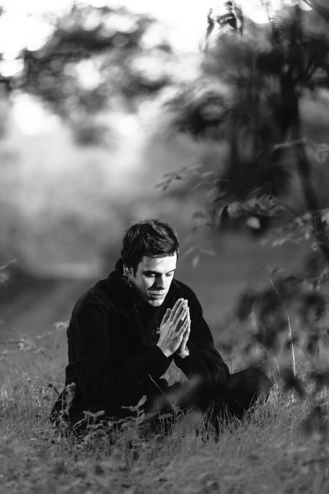
- Promotes high performance under duress
- Helps develop and foster gratitude/when in gratitude more situations to be grateful for come your way
- Long lasting after effects
- You can reap the rewards of having a feeling of connectedness rather than always thinking of self and when you feel connected, you work better as a team. Working better as a team means more success, more focus and more results
- Decrease in anxious thoughts and feelings as well as mild depression
- Reap the rewards of the body brain connection/if you are healthier, you are more productive
- Meditation can help you set and achieve goals
- Meditation can foster healthier relationships. If you are healthy and happy and at peace, then so will those around you be
- Increases focus
- Increases creativity
- Increases motivation

How to start as a beginner
Any new endeavor takes time to get used to. Just like anything else, you don’t want to jump in too much too soon. If you are exercising for the first time, you certainly wouldn’t run a 5K on the first day. Here are a few tips to get you started:

- Start slow – no matter how excited you are about beginning your meditation journey, it’s important to start slow. You don’t want to get overzealous and fall short. Many times when people start something new they go all out and get overwhelmed before they even begin. They have good intentions, but they don’t always stick with it. Meditation can be overwhelming in the beginning until you learn how to train your brain and guide yourself back to center.
- Set up a space – It’s important to set up a space that you can call your own. It does not have to be anything elaborate. It just needs to be someplace to call your own. It could be a corner of your den or in front of the window of your bedroom on the floor. Whatever it is, make it your own.
- Create a routine – it’s important just as you would with any new endeavor to create a routine. If you are going to alternate one morning with one evening and then a midday set of 10 minute meditations, keep to your routine. If you want to do it every other morning and alternate this with every other night, then stick with that routine.
- Stand in integrity and do what you say you will when you say you will – if you say you are going to take on the practice of meditation, then take it on whole heartedly. Set an example for the rest of your family and show them what it looks like to be a role model in integrity.
- Get a partner - don’t go it alone – meditation can be fun when you partner with other people. Find an accountability partner or better yet, find someone to join in on the fun with you.
- Let everyone know you are taking on this practice whether they want to join you or agree with you – be up front and clear that meditation is important to you and you fully intend to reap the benefits and they will reap the rewards as well when they see a brand new you.
Types of meditation:
There are several types of meditation practices you can look toward. Here are just a few you might want to explore and uncover:

- Mindfulness
- Zen
- Kundalini
- Transcendental

As you can see, meditation has a multitude of benefits. These benefits make their way into your mind, body, and spirit. Not only do you reap the rewards and benefits of incorporating meditation into your daily life, so does everyone else around you.

Meditation is not difficult to learn and it is not difficult to keep up the pace. With only 10 minutes a day, you could be on your way to a brand new you. You’ll be glad you did and your family, friends, and co-workers will be thrilled you did, too.

